DCF255 Lab policies:

* **Lab exercises are due on their assigned due date which is 1 week from the original lab assignment date**.  Labs submitted after one week will be subject to the late policy.
* **Labs will be unavailable after 2 weeks that the lab assigned**.
* You have two attempts to submit the lab report. But if you use 2nd attempt then you have to submit all lab reports again. I will mark your last attempt.
* Labs can be resubmitted, after the due date but with the penalty
* Late graded work will lose 15% of the total mark per day. All graded work must be completed to receive a final grade.
* **To receive a mark in your lab, all screenshots MUST include your name. If you don’t have it you will lose 50% of lab’s mark. To do this you have two options:**
  + Create a desktop background with your name on it. You can use paint and create a simple background with your name and set it as a tile on your background directly from the Paint app. Like:

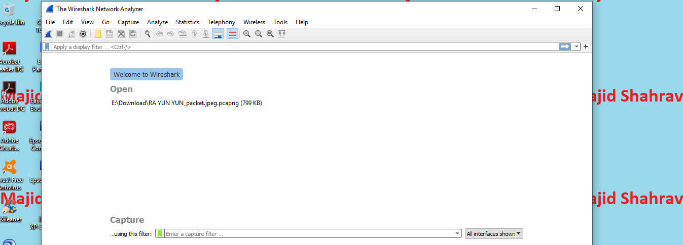

* + please open a browser like Google Chrome and login to My.Senecacollege. Then press F11 and you will see the browser changes to full screen and your full name will be appearing at the top, right-hand side of the screen. Use this webpage as your work background. Check the picture:

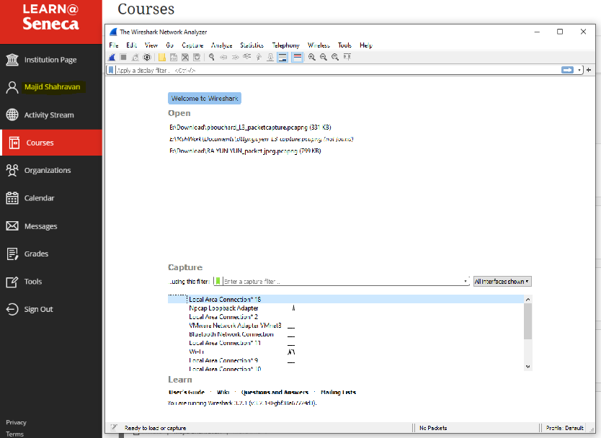

**Cheating and Plagiarism**

* ■ Please ensure that you follow Seneca College Academic Policy when you do your work. The following link, from the School of Computer Studies website, has some helpful information: <https://scs.senecacollege.ca/page/academic-honesty-policy>
* ■ You may collaborate with others while you are doing the lab exercises, however, the hand-in must be your own work
* The written assignment sources for web and other material must be referenced using proper APA footnotes and bibliography.